**Salesforce Admin 2 Go by Simon Fell**

* Source code is in the source.zip file.
* AdminApp.apk is a signed build of the app ready for installation.
* Works on Android 2.1 and up.

**Feature Summary**

* OAuth login to both production & sandbox instances. No need to login when returning to the app later.
* view recently accessed user records or search for users by name, works efficiently even for organizations with thousands of users.
* view user details including their profile photo (requires Android 2.2+) title, username and contact info.
* Contact the user via email/phone/SMS.
* Perform a password reset.
* Toggle the Active flag of the user.
* Clone the user into a new user, setting the new usename, name and email address.

**Screen Shots**

The next pages show screenshots of the various features.

**Login**.

Use the menu button to select between production and sandbox.

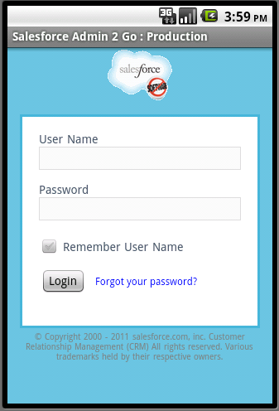 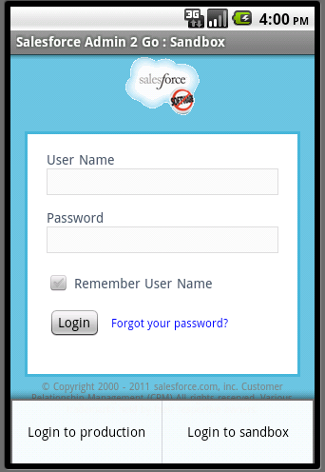

Once you’ve successfully logged in once, your oauth token will be saved, and subsequent launches of the app will verify the token and then proceed directly to the list view.

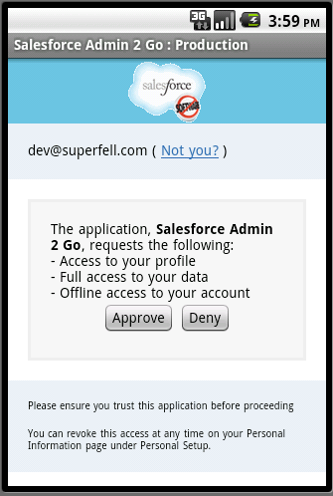 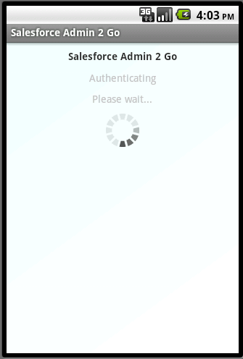

**User List View**

This appears after login, by default it’ll show the recent list of user records (as tracked by the MRU on the server). You can do a search by name, by typing in the search box. Notice the progress spinner in the title bar while API calls are being made. Tap on a user row to goto the detail page.

. 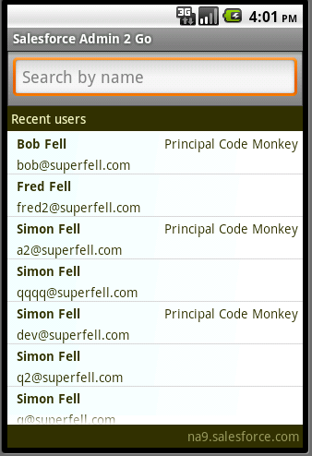 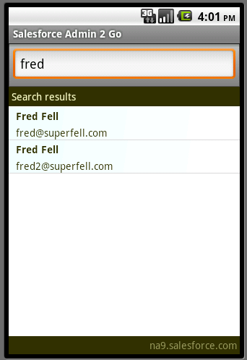

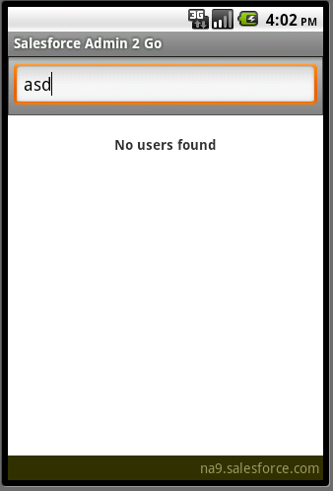

**User Detail View**

Here you’ll see more details on the user, including their chatter profile photo (if they have one, this photo loading requires Android 2.2) You can tap any of the links in the contact section to send an email, call, or SMS the user. The action section at the bottom allows you to do a Reset Password operation, toggle the Is Active state, or start the clone user screen.

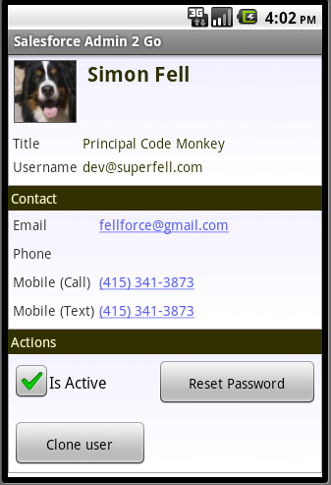 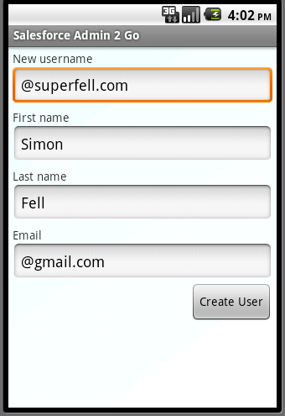

If you tap clone user, you’ll be taken to the clone page, where you can enter the new Username, first & last name, and email address for the new user record. Hit create user when you’ve enter the info. All of the creatable data (including custom fields) from the source user will be copied over to the new user.